AMS 333 HW# 2

Ivan Tinov

110255332

Ivan Tinov 110255332

***Analysis of Bacterial Growth***

**Introduction**

The study of bacterial growth is a vast field that can be modeled in various ways, some of which will be explored in this analysis. Bacterial populations grow exponentially when the population count is small, however as the population grows more food and resources are depleted and hence there is a drop in the growth of the population. Hence, when analyzing the growth of higher populations of bacteria, a different model must be analyzed with factors that account for the exhaustion resources that these bacteria need to populate. The MATLAB language is a powerful language and tool that allows us to simulate the mathematics that are involved in computing these models that are applicable to real-life bacterial growth. Creating plots allows the ability to analyze data in visual manner that enables us to see trends in the growth of bacteria.

**Methods Analysis**

Simplistic bacterial populations, such as that of *E. coli*, are heavily studied in scientific and mathematical fields because of their simplicity. Their population growth can be described by the exponential growth equation, *N(t) = No*2^(t/r)*, where *N(t)* is the population growth after a specific time interval, *t*, *No* is the initial population, and *r* is the time it takes for the population to double (doubling time). Other equations such as the Exponential Logistic model that uses the Forward-Euler method can examine bacterial growth under more complex conditions.

**Exponential Growth**

As stated above, the growth of simple bacteria like *E. coli* can be represented using the exponential growth equation, *N(t) = No*2^(t/r)*. At initial conditions, it is assumed that one *E. coli* bacteria is present in the dish at time, t = 0. Through observation, the doubling time, *r*, is approximately 20 minutes. Figure 1 below displays the growth of this bacteria over the course of one day (24 hours). Likewise, Figure 2 displays the final population of the bacteria at the end of 24 hours, N(t) = 4.7224*10^21. Each bacteria is said to have a dimension of 2 um * 1 um * 1 um, which is equivalent to (2 * 10^-6 m) * (1 * 10^-6 m)^2 = 2 * 10^-18 m^3. Hence, by a simple calculation, we can find the total volume occupied by the 4.7224*10^21 bacteria: (4.7224 * 10^21 bacteria) * (2 * 10^-18 m^3 per bacteria) = approximately 9444 m^3 of volume occupied. An initial population of 100 bacteria placed in 1 L of liquid growth medium will take around 16 hours to occupy the whole 1 L space. Hence, 2 * 10^-18 m^3 per bacteria = 2 * 10^-15 L per bacteria and 1 L / 2 * 10^-15 L per bacteria = 5 * 10^14 bacteria (N(t)). Solving for t = r * log(N(t)/No)/log(2) = 20 minutes * log(5 * 10^14/100)/log(2) = approximately 844 minutes or around 14 hours. Therefore, it would take about 14 hours to get the maximum number of bacterial cells.

**Forward-Euler Exponential Logistic**

The Forward-Euler Exponential Logistic model allows for the representation of bacterial growth in a more complex manner that allows us to observe bacterial growth in higher carrying capacities. Using the logistic equation, *dN/dt = Ro * N(t) * (1 – N(t) / K)*, in which *Ro* is the unrestricted growth rate, *N(t)* is the population growth after a specific time, and *K* is the carrying capacity of the environment that the bacteria are grown in. The graph of the logistic model is shown in Figure 3. The logistic equation is modeled after a differential equation that helps describe how the population changes and grows over a period of time. Integrating the above equation gives: *N(t) = K * No * e^(Ro * t) / (K – No + No * e^(Ro * t))*. Similarly, as the exponential equation, this equation describes the population growth after a specific time, t, obviously with a more complex nature that allows for higher carrying capacities. Further exploring the equation of N(t), we can deduce that as time increases to higher values, the exponential term, *e^(Ro * t)*, in the numerator cancels out with the denominator and the equation just becomes *N(t) = K*, equivalent to just the carrying capacity. As stated, the carrying capacity for *E. coli* is roughly 1 * 10^9 cells per mL. Thereby, the value for the unrestricted growth rate, *Ro,* can be calculated from the doubling time, *r*, by using a low value for the time, *t.* Doing this will result in a value roughly equal to 2.08 for *Ro*. Using this, the logistic model reaches its carrying capacity at a time identical to the exponential model (roughly 14 hours). Therefore, the logistic model has the same results as the exponential model.

**Forward-Euler Extended to Different time values**

The Forward-Euler method is a first-order numerical procedure that is used for solving ordinary differential equations with a given initial value. It is also an iterative method, meaning that previous values are added back to the equation and that value is multiplied by the given time step to move on to the next value, progressing the computation as time is increased. The Forward-Euler equation is described as: *x(t + Δt) = x(t) + dx/dt(Δt).* Figure 4 shows various plots using the Forward-Euler Equation with both exponential growth and the logistic equation, using a difference, *Δt,* of a single hour. Different time steps, *Δt,* of 0.0625, 0.125, 0.25, 0.5, and obviously 1 hour were used to compare the change in the curve using the Forward-Euler method. As we decreased the time steps from 1 hour, to 0.5 hours there was the biggest change in the curve as opposed to 0.125 to 0.0625 hours where there was little change in the curve of the graph. Further values of *Δt* lower than 0.0625 can be tested but the change in the curve will be even more miniscule.

**Diagrams**

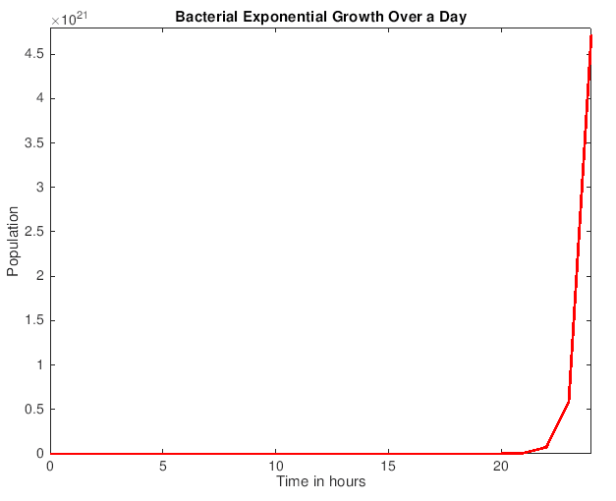

Figure 1



Figure 2

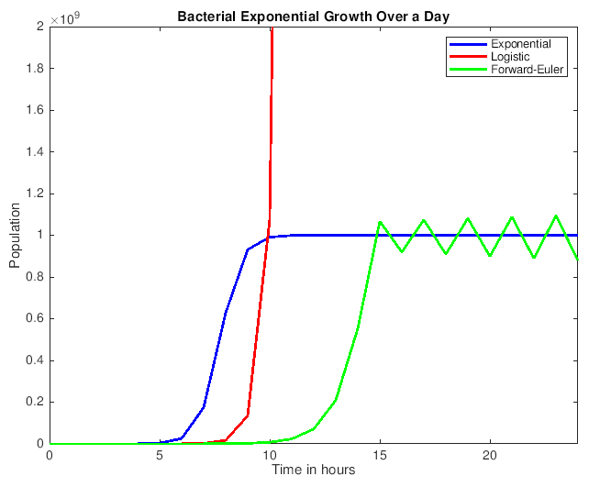

Figure 3

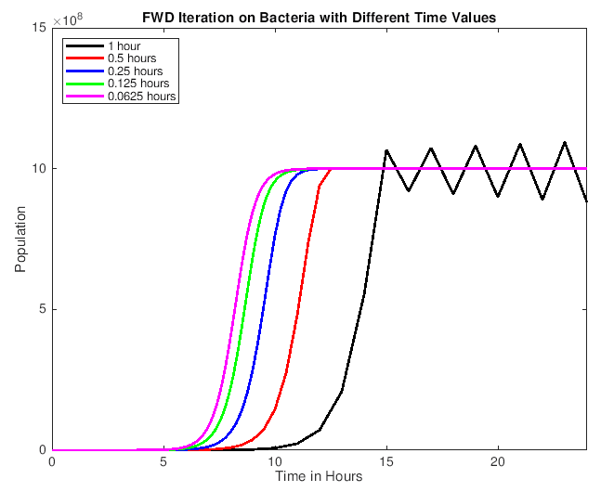

Figure 4

**Matlab Code**

1. *exponential_growth.m*

a = 0:24;

b = 3*a;

c = 1*pow2(b);

plot(a,c,'r','LineWidth',2);

xlabel('Time in hours');

ylabel('Population');

title('Bacterial Exponential Growth Over a Day');

axis([0 24 0 4.8*10^21]);

disp(c(25));

1. *fwd_exponential_logistic.m*

a=0:24;

s=size(a);

b=zeros(s);

for q=1:25

c=(q-1);

Ro=c*2.08;

b(q) = (10^9) * (100*exp(Ro) / (10^9 - 100 + 100*exp(Ro)));

end

plot(a,b,'b','LineWidth',2);

hold on;

c=3*a;

b=1*pow2(c);

plot(a,b,'r','LineWidth',2);

t=0:24;

a=zeros(25,1);

a(1)=100;

for n=1:24

a(n+1) = a(n) + 2.08*a(n) * (1-a(n) / 10^9);

end

plot(t,a,'g','LineWidth',2);

xlabel('Time in hours');

ylabel('Population');

title('Bacterial Exponential Growth Over a Day');

axis([0 24 0 2*10^9]);

legend('Exponential','Logistic','Forward-Euler');

hold off;

1. *fwd_extended.m*

t=0:24;

a=zeros(25,1);

a(1)=100;

for n=1:24

a(n+1) = a(n) + 2.08*a(n) * (1-a(n) / 10^9);

end

plot(t,a,'k','LineWidth',2);

hold on;

t=0:0.5:24;

a=zeros(49,1);

a(1)=100;

for n=1:48

a(n+1) = a(n) + 0.5 * 2.08*a(n) * (1-a(n) / 10^9);

end

plot(t,a,'r','LineWidth',2);

t=0:0.25:24;

a=zeros(97,1);

a(1)=100;

for n=1:96

a(n+1) = a(n) + 0.25 * 2.08*a(n) * (1-a(n) / 10^9);

end

plot(t,a,'b','LineWidth',2);

t=0:0.125:24;

a=zeros(193,1);

a(1)=100;

for n=1:192

a(n+1) = a(n) + 0.125*2.08*a(n) * (1-a(n) / 10^9);

end

plot(t,a,'g','LineWidth',2);

t=0:0.0625:24;

a=zeros(385,1);

a(1)=100;

for n=1:384

a(n+1) = a(n) + 0.0625*2.08*a(n) * (1-a(n) / 10^9);

end

plot(t,a,'m','LineWidth',2);

xlabel('Time in Hours');

ylabel('Population');

title('FWD Iteration on Bacteria with Different Time Values');

axis([0 24 0 15*10^8]);

legend('1 hour','0.5 hours','0.25 hours','0.125 hours','0.0625 hours', 'Location', 'northwest');

hold off